To: [insert Capstone instructor and GTA]

From: [insert team member names here]

Date: [date due]

Subject: [insert memo subject here]

The project is about cleaning the traffic sign boards without interrupting the traffic flow and to do so a design has created which can clean the traffic sign boards and no traffic will get disturb from it. The design consists of a drone system attached with the pipes, nozzle system and brush that cleans the sign board. The drone is connecting with the water tank places on the ground and attached with the hose that connects the water tank and reel to the drone, and the purpose is to provide the water and also provide the safety feature for the case of malfunctioning or any problem in drone, the hose and reel will take back the drone and keep it safe from falling. In this memo the defined customer requirements will present along with the engineering requirements and will describe each engineering requirement with the tolerance and the justification for the tolerance. Further in this memo, it will talk about the changes made in the design and the reasons will provide about why the changes have made into the design.

The customer requirements have defined by the client and the team developed a table of it and from those requirements the team has developed the technical requirements given the name as engineering requirements. These engineering requirements are technical values so these can measure physically in the design to verify the product is fulfilling all the client requirements. As the technical values have defined earlier as well so in this memo it will talk about their tolerance values, and why such tolerances have assigned, will discuss in this memo.

The design changes include some minor changes in the design and it will talk in details with the clarification of why the changes have made in the design and what are the effects of these design changes on the design.

# Customer Requirements (CRs)

Customer requirements are the project description in a tabular form which contains all the important points of the project define by the client. The purpose of making the customer requirements table is to highlight the main part of the project so that when the project will be ready it can clearly examine through the customer requirement whether the objectives of the project have achieved or not. Another reason to do the customer requirements I to understand the project because sometime the project description is not clear enough to understand the project so customer requirement helps at that time. The customer requirement for this project has been given in the table 1.

Table 1: Customer Requirements

|  |  |
| --- | --- |
| **Customer Requirements** | **Weightage** |
| Do not interrupt the flow of traffic | 9 |
| Failsafe | 8 |
| Collect Water Drops | 7 |
| Clean in short time | 6 |
| Clean without damaging the coating | 5 |
| Safe to Operate | 4 |
| Cost within budget | 3 |
| Durable and Robust Design | 2 |
| Reliable Design | 1 |

Do not interrupt the flow of traffic requirement is meeting the objective as in the project description it has asked to develop such design which cannot interrupt the traffic flow so it is directly meting the objective. Failsafe is also the highlighted point in the description so it is meeting the objective as well. Collect water drops, meets the objective as the cleanliness can perform through the water. Short time cleaning meets the objective as to perform the task in quick way according to the objective of project. Clean without damaging the coating meet the objective that state safe to use without causing any trouble, safe to operate the device meet the objective of safe to use, cost within budget is a necessary requirement because budget has given so it must be within that budget and that’s the regular objective of any design project, durable and robust design meet the objective as it is necessary for the design to be long lasting and can easily move from one place to another place so it is meeting the objective of safe to use. Reliable design meets the objective as it need to work all the time in all the conditions.

For the customer requirements, all the requirements have mentioned earlier in the preliminary report from ME 476C and there was not any single customer requirement which was missing in it and added after that. So, the current customer requirements are exactly same as stated before and no changes have made in it. The reason for making no change is that these customer requirements are fully justifying the project description without missing point.

# Engineering Requirements (ERs)

Engineering requirements are the one which developed from the customer requirements and these are the technical details about the project so that the project can develop using these physical values and these physical values can test through different procedures when the product will develop. Table 2 has shown the engineering requirements generated for this project.

Table 2: Engineering Requirements

|  |  |  |  |
| --- | --- | --- | --- |
| **Engineering Requirements** | **Target Values** | **Tolerance** | **Justification** |
| Flight Time | 20 minutes | $$± 5 min$$ | 20 minutes have given, 5 minutes tolerance so that it can work easily in that limit |
| Height of Flight | 100 feet | $$± 10 ft$$ | The normal height required is around 100 feet so tolerance is 10 feet above or below this value |
| Water tank | 20 liters | $$± 3 liter$$ | 20 liter of water is enough to clean boards, and 3 liter of tolerance can easily work for it |
| Device Weight | 30 lb. | $$± 5 lb.$$ | 30 lb of device is enough to lift up and 5 lb of tolerance to bear the extra load |
| Reliable in temperature | -10C to 40C | $$± 5 C$$ | High range of temperature variation can wear in this range with tolerance of 5 degrees at each point |
| Durable | 2200 GPa | $$± 200 GPa$$ | Bear the shear stress of 2200 GPa to show durability, 2200 GPA is high value so tolerance range is high as 200. |
| Long Power Backup | 30 Mins | $$±5 min$$ | Power require to run the drone and reel must be 30 minutes while the tolerance is 5 minutes |
| Failsafe rotation speed | 25 rpm | $$±5 rpm$$ | The rotation of reel must 25 rpm with the tolerance of 5 rpm. |
| Hose Height | 65 ft | $$± 5 ft$$ | Hose will provide the height of 65 feet with the tolerance of 5 feet. |

Flight time is the time to keep the device in the air and that is necessary for the device because it takes around 10 to 15 minutes to clean a board so the range of 20 minutes flying is enough for cleaning. Height of flight is defining the height that will take off by the system and the product will fly to 100 feet maximum to clean the boards so any board in the height of 100 feet can clean through this device.

Water tank carrier is basically carrying capacity of the device for the water, and this would be 20 liters which is enough to clean the boards together.

Device weight is basically the weight of the device that will carry by the device itself during the flying and the weight is 30 lb. so it can easily lift up in the air and fly.

Reliable in temperature means the device can withstand again harsh temperature either in cold season when temperature goes below 0 degrees or in summer season when temperature goes above 30 degrees. The device must be reliable in such a range of temperature.

Durable means the device must be strong and for this purpose it should have the shear stress of 2200 GPa so that it will not easily break in any condition. For the long power backup, the device must connect with the source that will provide consistent power of 30 min so that device can easily clean the boards. Failsafe rotation speed means the product will get safe from some sort of motor so that motor must rotate with the speed of 4 m/s so that drone will not fly to the ground because of the gravity. The hose height is the height of hose that will support from the ground and provide the water and electric power to the drone for working capability so the height of hose is around 65 feet.

## ER #1: Flight Time under 25 minutes

### ER #1: Flight Time under 25 minutes - Target = 20 minutes

The flight time is the time of drone staying the air, so that time will calculate the total flight time and for this drone it has to be in the air for 20 minutes, while the expected value is more than 20 minutes but the target is to achieve 20 minutes at least and stay in the air. So that the sign boards can easily clean during this time duration. This is important to the project because longer the flight time can clean the sign boards in better way and hence can make the project efficient so efficiency of the project depends on the flight time.

### ER #1: Flight Time under25 minutes – Tolerance = +/- 5 minutes

The flight time tolerance has selected 5 minutes, so the target was set to 20 minutes and it can reach upto 25 minutes while it can also go down to 15 minutes which is still acceptable time to clean the sign boards so the 5 minutes of tolerance is fine for the flight time and it is important to have the tolerance of 5 minutes because in this way the flight time will vary between 15 minutes to 25 minutes and in this time board can easily clean and make the device efficient, that’s why it is important.

## ER #2 (Changed from fall): Height of Flight under 110 feet

### ER #2: Height of Flight under 110 feet – Target = 100 feet

The height of flight is the peak of height that can easily achieve by the drone and this ER has changed from last semester because before the team was considering that only 20 feet is enough to clean the sign boards but now the height of sign boards have measured and found that they vary from 30 feet to 80 feet, therefore the drone need to go to 100 feet height and that’s why this ER has changed. This ER is important to the project as the main work is to clean the sign board and if the drone cannot reach to that height then it will useless to make this system therefore whole working of the project is depending on height which makes is quite important to the project.

### ER #2: Height of Flight under 110 feet - Tolerance = +/- 10 feet

The tolerance of height has selected to 10 feet because the height of 90 feet to 110 feet is acceptable and reasonable for cleaning the sign boards so having the tolerance of 10 feet is suitable for the project and this important because not achieving to the minimum height of 90 feet will make the device not useful so it is quite important.

## ER #3 (changed from fall): Water tank under 23 liters

### ER #3: Water tank under 23 liters - Target = 20 liters

This ER has changed from the fall as well, before it was decided to make the water tank within the drone but in that case small amount of water can carry by the drone that’s why it was 2 liters before but now the changes have made in the design and decided to make the water tank at the ground so for that tank 20 liters is the targeted value while it will be under 23 liters. This is important as not enough water is available on highway then how the sign boards can clean so it is one of the basic things need in this project which make it quite important for the project.

### ER #3: Water tank under 23 liters - Tolerance = +/- 3 liters

The tolerance has set to 3 liters so the maximum water capacity can reach to 23 liters but the team will make the water tank that will save 20 liters or little less. And it is important as it is the essential part of project to have lot of water for cleaning purpose.

## ER #4 (Changed from fall): Device Weight under 35 lb. Flight Time

### ER #4: Device Weight under 35 lb. - Target = 30 lb.

The weight of device is an important aspect for any flying product because flying time, flying height and flying capability depends on the device weight before it was decided to make a small drone that will have maximum weight of 5 kg or less but now the drone capability has increased and it need to fly 100 feet in the air therefore need more propellers and motors so the ER has changed from fall semester from 5 kg to 30 lb. as targeted value while the weight need to be under 35 lb. for sure.

### ER #4: Device Weight under 35 lb. – Tolerance = +/- 5 lb.

The tolerance selected for the weight is 5 lb. so it can maximum go up-to 35 but the team will keep the weight under 30 lb. and having the weight less than 30 lb. will increase the flight time and height of flight as well.

## ER #5: Reliable in Temperature

### ER #5: Reliable in Temperature under 45 C – Target = 40 C

To make the device reliable it has to be operational in each kind of temperature from cold temperature to high and hot temperature. The target has set to 40 degrees so the device can work in 40 C without any problem and can also work in -10 C without having any problem. This shows that the device is reliable and it is important for the design because it shows reliability.

### ER #5: Reliable in Temperature under 45 C - Tolerance = +/- 5 C

The tolerance selected for the temperature is 5 degrees, that means the device can work in 45 degrees as well so this tolerance will utilize in the product to make it reliable and can also work in -15 C at the tolerance value hence it shows the reliability.

## ER #6: Durable under 2400 GPa

### ER #6: Durable under 2400 GPa - Target = 2200 GPa

The durability of device can determine from the stress it can bear and the stress target is 2200 GPa, while the maximum stress to bear is 2400 GPa that has to be present in the device and it is important to show the durability of the product.

### ER #6: Durable under 2400 GPa - Tolerance = +/- 200 GPa

The tolerance for the durability has set to 200 GPa so from the target value it can bear 200 GPa extra stress hence make it quite durable.

## ER #7 (changed from fall): Long Power Backup Above 25 min

### ER #7: Long Backup Above 25 min - Target = 30 min

This ER was not present before so it has added now in the table, and the reason for adding this ER is that the product needs long time power back up so it can easily wash out the sign boards and get back to the position or move on. So, the whole process will take no more than 10 minutes but still the long power back up must be more than 25 min and the target is 30 minutes while the power is providing from the external source so it must deliver continuous power of 30 minutes to keep the device running.

### ER #7 Long Backup Above 25 min - Tolerance = +/- 5 min

The tolerance decided to set for 5 minutes so that the power varies from 25 min to 35 min is fine for the device.

## ER #8 (Changed from fall): Failsafe Rotation Speed Above 20 rpm

### ER #8: Failsafe Speed above 20 rpm - Target = 25 rpm

This ER was not present before in the preliminary report because it was not decided at that time about the failsafe setting. The failsafe speed means the device will roll over through the reel and hose so the reel rotation speed must be enough that it will roll over the drone before it falls to the ground because of gravity so the speed need to be faster than the gravity and hence the target set is 25 rpm rotation speed of motor but it can work above 20 rpm at any speed. This is important for the device to keep it safe in case of any malfunctioning.

### ER #8: Failsafe Speed above 20 rpm – Tolerance = +/- 5 rpm

The tolerance selected for this ER is 5rpm so that the rotation will move with at least 20 rpm speed or maximum with 30 rpm but the team will keep the speed to 25 rpm.

## ER #9 (Changed from fall): Hose Height above 60 feet

### ER #9: Hose Height above 60 feet – Target = 65 C

This ER was not present in the preliminary report and it has added now because the idea of hose was not decided at that time and now it present in the design and it has decided to make the hose of 65 feet, with the minimum value above 60 feet so that it can easily attach with the drone for the maximum height sign board. And it is important for the design at is providing the failsafe to the drone.

### ER #9: Hose Height above 60 feet - Tolerance = +/- 5 C

The tolerance selected for the hose height is 10 feet so that it can be between 60 feet to 70 feet while the target value decided is 65 feet and team will make the hose of 65 feet.

# Design Changes

At the start of the project considering the preliminary report and final design selection, the design selected was similar to the one it is now but the problem was about the battery backup and water source. The selected design from last semester was this

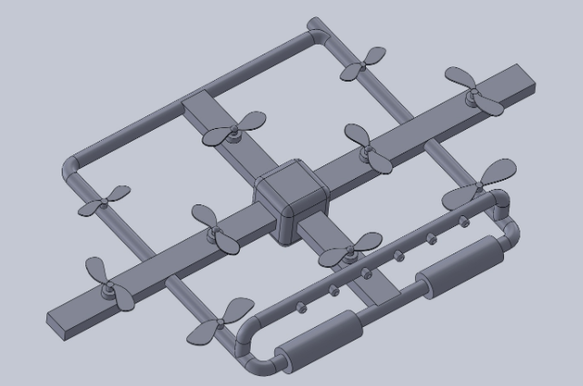

Figure 1: Capstone I selected design

This design was decided to get the power from the battery and then decided to get the power from outer source but it has not decided at that time how to get the power source connects with the water. Also, the design was considered to have the water bucket along with the drone but later on we have decided to make these changes and now the final design is using the hose to make the connection with the drone and it stand on the ground and there is a reel connected with the hose and there is a water tank connected with the hose as well. And the power wire is also passing by the hose, in this way the drone will get the water supply and electric power and also the failsafe feature.

## Design Iteration 1: Change in Water tank discussion

The original design before was to have the water tank carrying with the drone and yet it has not designed but just the idea has selected that the bucked or bottle will hold with the drone and it will supply the water to the nozzles for cleaning purpose. The motivation for changing this design is that in this way the device will not get to heavy and surplus water will available. And this water can easily use by the drone for long time. The design of the water tank has shown below

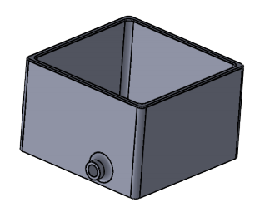

Figure 2: Water Tank

Before that the water tank was using of 3 liters and now the size has increased and the capacity of this water tank is more than 30 liters but the team will keep 20 liters of water in for the use. Hence it is clear that

$$3 Liter>20 Liter$$

So, the above condition is the main purpose why the water tank has designed separately and made this change in old design.

## Design Iteration 2: Use of Hose

In the capstone 1 design the hose was designed and it was not decided yet how to use the hose but recently it has designed that the hose will use in the form of a straight pipe which is foldable and can increase and decrease the size of it. And the drone is connecting through the hose using flexible pipe. And the reel, water and electricity are passing through the hose and connected with the drone. The design of drone has shown below

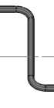

Figure 3: Hose

The above hose has a height of around 65 feet and it will support from the ground and connect the reel with the drone. The motivations for selecting the hose that will attach with the ground are

* It will provide the failsafe to the system
* Water will supply to drone from the outer tank
* Electric power will pass to the drone through the hose

With these three features it has decided to put the hose in the design. And the length of hose has decided to keep at 65 feet with the tolerance of +/- 5 feet.

$$Average Length of Sign Board=50 feet$$

$$Hose Length=65 feet$$

Hence hose can easily reach to the sign board and connect with the drone.

## Design Iteration 3: Use of Reel

The next thing which has added to the design is reel, this reel is an automatic reel which is connecting with the drone for the fail-safe purpose. In the capstone 1 design it has decided by the team how to provide the failsafe to the system so the reel was not present in that design but now the design has changed and added the reel in it with the automatic function in such a way that when the drone will malfunctioning or stop working, reel will instantly pull over the connection with drone and bring the drone back to the ground. Here is the reel attached with the hose to the drone.

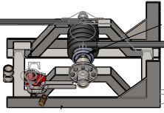

Figure 4: Reel

The reel is working with the motor and the motor has to move with the speed that the drone will not fall because of gravity and it will roll over because of reel.

Consider that the object (drone) is present at the 50 feet.

$$distance=S=50 feet$$

$$distance=S=15.24 m$$

Now we need to find the speed of the object falling freely due to gravity

$$v=\sqrt{2*d*g}$$

$$g=9.81\frac{m}{s^{2}}$$

$$v=\sqrt{2*15.24*9.81}$$

$$v=\sqrt{299.0088}$$

$$v=17.2919\frac{m}{s}$$

So, the speed of the object falling downward because of the gravity at a height of 50 feet is v = 17.2919 m/s.

Now the rotation of motor can define as

$$ω=\frac{v}{r}$$

$$r=radius of motor$$

$$r=0.1 m$$

$$ω=\frac{17.2919}{0.1}$$

$$ω=172.92 rpm$$

Hence the motor needs to rotate with the speed higher than 172.92 rpm to save the drone from falling. Hence the minimum revolution per minute is 20 revolution per minute. And it has stated already in the engineering requirements.

## Design Iteration 4: Use of Wheels

In the previous design no wheels were added in the design but as some modifications have made into the design so it has decided by the team to put two wheels at the front of design so that the device can easily move on the ground from taking the device from one place to another place. But there is another benefit of using the wheels, and that is the device will safely land to the ground when it will come back from the height, and it will also provide safety to the device while the device will be rescued through the failsafe option. In failsafe situation the drone will not hit hard on the ground because of the presence of wheels. The wheels added to the design have shown below

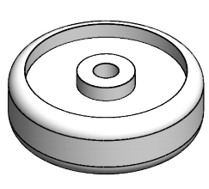

Figure 5: Wheels

After making all these changes into the design following final design has developed

## Design Iteration 4: Use of Wheels

Another change has decided to make in the design is the material of brush, before that it was decided to make nylon brush that will clean the board but because nylon brushes are not water absorber and in this way the water will fall down to the ground. And hence the project wants the water not be fall down on the surface, after that the team has decided to use the towel fabric cover the brush rollers, there are two benefits of using towel fabric for the brush

1. Towel fabric can absorb the water
2. It is soft and will not cause any damage on the board

With the above two reasons, team has decided to use the towel fabric so that all the water present on the sign board will easily absorb by the fabric brush and no water will fall down on the surface, and second thing is that when this brush will rub on the sign board, it will remove all the dust present on the board and towel fabric will clean the boards in good quality. While the soft stuff nature of towel fabric will not damage any part of the sign board not even the writing stuff present on the board so using the towel fabric is better as compare to the nylon stuff for the cleaning purpose.

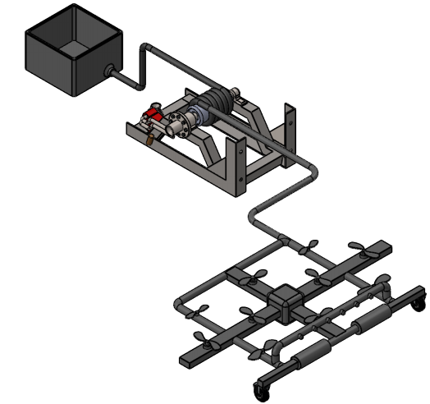

Figure 6: Final Design (After Changes)

In the above design, water tank, automatic reel, hose and wheels can clearly see and these are the things which have added into the design to the design operational and fulfil the client requirements. Now the above design can work easily for cleaning the sign board.

# Future Work

The next task for the future is to work on the design to finalize it for working and make the reel engine in working by analyzing the required motors that will suit for the reel. The tasks have presented in the schedule Gantt chart.

## Further Design

Because of current situations, it has decided not to manufacture the device but in terms of manufacturing the device will manufacturing using the light weight pipes of PVC and the structure will develop using the glue for connections. And then the motors will install in the propellers and will make the connections as per the design.

## Schedule Breakdown

The Gantt chart has given below

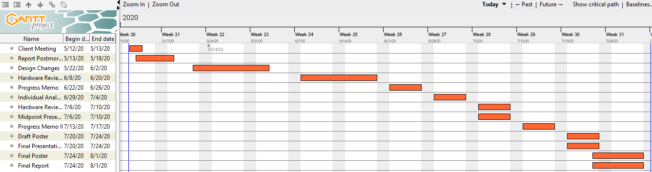

Figure 7: Gantt Chart

And the work breakdown structure dividing between the group members have mentioned below in the table that will perform in the future.

Table 1: Work Break down

|  |  |
| --- | --- |
| Name | Tasks |
| Abdalla and Saad | Hardware Review 2 CAD |
| Abdulrahman Ahmed | Coding part |
| Mohamed | Writing |
| Mosaad | Calculations |
| Abdullah Altamimi | Reviewing the work |
| Abdulrahman Ahmad, Abdalla and Saad | Website Check 2 |
| Mohammed, Musaad and Abdullah | Presentation |

# References

[1] H. Hype, “Liner to Angular Velocity”, available [online], <http://hyperphysics.phy-astr.gsu.edu/hbase/rotq.html>